Sample report for growth curves

## Table summarizing raw data

|  |  |  |  |  |  |  |
| --- | --- | --- | --- | --- | --- | --- |
| sampling_date_time | exp_time | a1 | a3 | l1 | l2 | l3 |
| 2019-07-09 12:00:00 | 0.000000 hours | 0.020 | 0.020 | 0.020 | 0.020 | 0.020 |
| 2019-07-09 16:05:00 | 4.083333 hours | 0.027 | 0.020 | 0.022 | 0.022 | 0.027 |
| 2019-07-10 09:50:00 | 21.833333 hours | 0.087 | 0.087 | 0.057 | 0.082 | 0.086 |
| 2019-07-10 16:50:00 | 28.833333 hours | 0.129 | 0.137 | 0.072 | 0.104 | 0.111 |
| 2019-07-11 10:03:00 | 46.050000 hours | 0.247 | 0.258 | 0.102 | 0.114 | 0.126 |
| 2019-07-11 16:07:00 | 52.116667 hours | 0.299 | 0.302 | 0.110 | 0.110 | 0.126 |
| 2019-07-12 09:48:00 | 69.800000 hours | 0.410 | 0.428 | 0.137 | 0.111 | 0.131 |
| 2019-07-12 16:30:00 | 76.500000 hours | 0.426 | 0.432 | 0.138 | 0.110 | 0.130 |
| 2019-07-13 10:35:00 | 94.583333 hours | 0.442 | 0.444 | 0.138 | 0.100 | 0.125 |
| 2019-07-13 17:52:00 | 101.866667 hours | 0.448 | 0.450 | 0.143 | 0.103 | 0.131 |
| 2019-07-14 13:10:00 | 121.166667 hours | 0.436 | 0.448 | 0.144 | 0.100 | 0.131 |
| 2019-07-15 10:27:00 | 142.450000 hours | 0.434 | 0.450 | 0.147 | 0.097 | 0.129 |
| 2019-07-15 16:42:00 | 148.700000 hours | 0.428 | 0.450 | 0.147 | 0.097 | 0.129 |
| 2019-07-16 09:28:00 | 165.466667 hours | 0.420 | 0.448 | 0.145 | 0.095 | 0.128 |

## Plot of growth curves

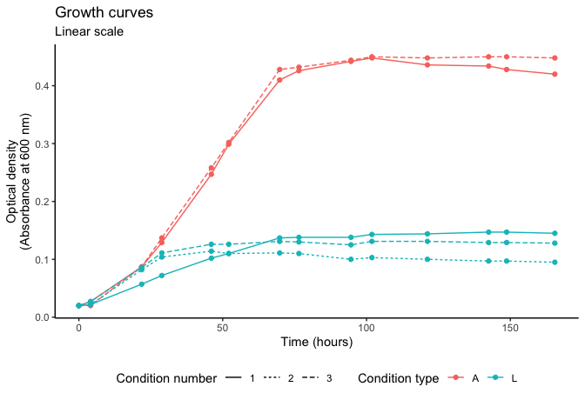

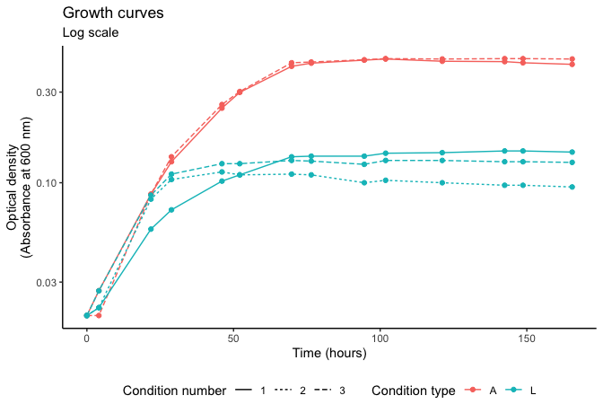

## Table of growth times—24 to 65 hours

|  |  |  |  |
| --- | --- | --- | --- |
| growth_conditions | start_time | end_time | doubling_time |
| a1 | 21.83333 | 69.8 | 21.44685 |
| a3 | 21.83333 | 69.8 | 20.86847 |
| l1 | 21.83333 | 69.8 | 37.91406 |
| l2 | 21.83333 | 69.8 | 109.79774 |
| l3 | 21.83333 | 69.8 | 79.00192 |

